Bookstore Management System
Project Report

Team ID | PNT2026TMID00921
Project Name | Bookstore Management System
Technology Stack | MongoDB, Express.js, React.js, Node.js (MERN)
Date | 19 July 2026

1. Introduction

1.1 Project Overview
The Bookstore Management System is a full-stack web application built on the MERN stack (MongoDB, Express.js, React.js, and Node.js) that provides a centralized digital platform for browsing, purchasing, and reviewing books online. The system supports three categories of users: customers who discover and purchase books, organizers (publishers/sellers) who manage inventory and fulfil orders, and administrators who oversee the platform end to end.
The application replaces the limitations of traditional physical bookstores, such as restricted operating hours, limited inventory visibility, and manual record-keeping, with an always-available, searchable, and trackable online experience. Customers can create accounts, search and filter books by category or keyword, add items to a shopping cart, place orders, and track delivery status in real time. Organizers manage their own inventory and pricing through a dedicated dashboard, while administrators approve organizer accounts, manage users, and moderate reviews.
On the frontend, React.js with Vite delivers a fast and responsive single-page application styled with Tailwind CSS, with the Context API managing authentication and cart state. On the backend, Node.js and Express.js expose RESTful APIs secured with JSON Web Tokens (JWT), while MongoDB with Mongoose handles schema-based data storage and validation. The system follows the Model-View-Controller (MVC) architecture for modularity, scalability, and maintainability.

1.2 Purpose
The purpose of this project is to design and develop a secure, scalable, and user-friendly e-commerce platform dedicated to book sales that:
- Provides customers with a convenient way to discover, evaluate, and purchase books online.
- Gives organizers the tools to manage inventory, pricing, and order fulfilment efficiently.
- Gives administrators centralized control over users, listings, and platform quality.
- Demonstrates the practical application of the MERN stack, RESTful API design, JWT-based authentication, and the MVC architectural pattern in a real-world e-commerce scenario.

2. Ideation Phase

2.1 Problem Statement
Problem Statement (PS) | I am (Customer) | I'm trying to | But | Because | Which makes me feel
PS-1 | a busy student who enjoys reading | buy books conveniently without visiting a physical store | local bookstores have limited stock, fixed hours, and no way to compare options remotely | I have limited free time between classes and other commitments | frustrated and unable to plan my reading in advance
PS-2 | an independent publisher/seller (Organizer) | reach a wider audience and manage my catalogue efficiently | manual record-keeping across multiple sales channels is time-consuming and error-prone | I lack a centralized system to track inventory and orders | overwhelmed and unable to scale my business

2.2 Empathy Map Canvas
Persona: Rahul, an engineering student and avid reader who prefers purchasing books online due to a busy academic schedule.
Category | Observations
Says | "I don't have time to visit a bookstore." "I want to compare prices and read reviews before buying."
Thinks | Wonders whether the book will be relevant and worth the price; worries about delivery timelines during exam season.
Does | Searches online for books, compares options, reads reviews, checks price and availability before ordering.
Feels | Anxious about wasting money on the wrong book; relieved when order tracking is transparent.
Pain Points | Limited store hours, no visibility into stock, no easy way to track orders, lack of genuine reviews.
Gains | Convenience of browsing anytime, transparent pricing, reliable delivery tracking, informed decisions via reviews.

2.3 Brainstorming
The team brainstormed the following features and prioritized them for the initial release based on customer value and implementation feasibility:
- Category and keyword-based book search with filters (genre, author, price)
- Secure JWT-based authentication for customers, organizers, and admins
- Shopping cart with automatic total calculation
- Real-time order status tracking (Pending → Processing → Shipped → Delivered)
- Organizer dashboard for inventory and order management
- Admin dashboard for approvals, user management, and review moderation
- Ratings and reviews to support future purchasing decisions
- Responsive, dark-mode-friendly UI built with Tailwind CSS
Ideas were grouped, voted on by the team, and shortlisted into must-have (MVP) and future-scope categories, forming the basis of the requirement analysis and sprint planning that followed.

3. Requirement Analysis

3.1 Customer Journey Map
Stage | Customer Action | Touchpoint | Emotion
Discover | Learns about the platform and visits the website | Landing/Home page | Curious
Register | Creates an account with name, email, mobile number, password | Sign Up page | Hopeful
Browse | Searches and filters books by category, author, or keyword | Books page | Engaged
Evaluate | Reads book descriptions, prices, ratings, and reviews | Book Details page | Analytical
Purchase | Adds books to cart and completes checkout | Cart & Checkout | Confident
Track | Monitors order status until delivery | My Orders page | Anticipating
Review | Submits ratings and reviews after receiving books | Book Details page | Satisfied

3.2 Solution Requirement
Functional Requirements
FR No. | Functional Requirement | Sub Requirement
FR-1 | User Registration & Authentication | Sign up, secure login, JWT session, role-based access (Customer/Organizer/Admin)
FR-2 | Book Catalog Management | Add/edit/remove listings, category tagging, pricing, stock updates
FR-3 | Search & Filter | Keyword, author, and genre-based search with category filters
FR-4 | Shopping Cart | Add/remove items, update quantity, auto-calculate total
FR-5 | Order Management | Checkout, inventory update, order status tracking
FR-6 | Organizer Dashboard | Inventory management, order processing, status updates
FR-7 | Admin Dashboard | Organizer approval, user management, review moderation
FR-8 | Ratings & Reviews | Submit and view reviews tied to purchased books
Non-Functional Requirements
NFR No. | Non-Functional Requirement | Description
NFR-1 | Security | Passwords encrypted; protected routes secured via JWT
NFR-2 | Usability | Responsive, intuitive UI built with Tailwind CSS
NFR-3 | Performance | API responses optimized for sub-second typical response times
NFR-4 | Scalability | MVC architecture and RESTful APIs support horizontal scaling
NFR-5 | Availability | Cloud-hosted deployment targeting high uptime
NFR-6 | Maintainability | Modular codebase separating routes, controllers, and models

3.3 Data Flow Diagram
Level 0 (Context Diagram): The Bookstore Management System sits at the center, exchanging data with three external entities — Customer, Organizer, and Administrator. Customers send registration, search, and order data and receive book listings, cart totals, and order status. Organizers send inventory and pricing updates and receive order notifications. Administrators send approval and moderation actions and receive platform activity data.
Level 1 (Process Breakdown):
- Process 1 – User Authentication: validates credentials against the Users data store and issues a JWT.
- Process 2 – Book Catalog Management: reads/writes the Books data store; used by Organizers to add/update listings and by Customers to browse/search.
- Process 3 – Cart & Order Processing: reads the Books data store for availability, writes to the Orders data store, and updates inventory.
- Process 4 – Order Tracking: reads/updates order status in the Orders data store, notifying Customers of changes made by Organizers.
- Process 5 – Review Management: writes to the Reviews data store and links reviews to the Books data store for display.
- Process 6 – Admin Control: reads/writes the Users and Books data stores to approve organizers, manage accounts, and moderate reviews.

3.4 Technology Stack
Layer | Technology | Purpose
Frontend | React.js (Vite) | Fast, responsive single-page application
Styling | Tailwind CSS | Utility-first, responsive UI design
State Management | React Context API | Authentication and shopping cart state
Backend | Node.js + Express.js | RESTful API layer for business logic
Database | MongoDB | NoSQL storage for users, books, carts, orders, reviews
ODM | Mongoose | Schema validation and object modeling
Authentication | JSON Web Tokens (JWT) | Secure, stateless session management
Testing | Postman | API endpoint testing
Version Control | Git & GitHub | Source control and collaboration
IDE | Visual Studio Code | Development environment

4. Project Design

4.1 Problem Solution Fit
Element | Description
Customer Segment | Students and general readers who prefer online book shopping; independent organizers/publishers seeking a sales channel
Jobs to be Done | Find and buy relevant books quickly; manage book inventory and sales without manual overhead
Pains | Limited store hours and stock visibility; no centralized way to track orders; time-consuming manual inventory management
Gains Expected | Convenient anytime access; transparent pricing and reviews; reliable order tracking; simplified inventory control
Pain Relievers | 24/7 online catalog with search/filter; real-time order tracking; organizer dashboard for inventory and orders
Gain Creators | Personalized browsing by category; automated cart totals; review-driven purchase confidence; centralized admin oversight
Product/Service | The Bookstore Management System web application (MERN stack)

4.2 Proposed Solution
Parameter | Description
Problem Statement | Traditional bookstores limit customer convenience and burden sellers with manual inventory and order management
Idea / Solution | A MERN-based online bookstore platform connecting customers, organizers, and administrators through role-based dashboards
Novelty / Uniqueness | Unified platform combining customer shopping experience with organizer inventory tools and centralized admin governance in a single system
Social Impact / Value | Expands access to books for time-constrained customers and provides independent sellers a low-overhead sales channel
Business Model | Commission on organizer sales and/or subscription-based organizer accounts (future scope)
Scalability | Modular MVC architecture and RESTful APIs allow new features, categories, and higher user loads to be added with minimal rework

4.3 Solution Architecture
The system follows a three-tier, client-server architecture aligned with the MVC pattern:
- Presentation Layer (View): React.js (Vite) single-page application, styled with Tailwind CSS, communicating with the backend via REST APIs over HTTPS.
- Application Layer (Controller): Express.js RESTful API handling authentication, book catalog operations, cart/order processing, and role-based access control, secured with JWT middleware.
- Data Layer (Model): MongoDB collections (Users, Books, Carts, Orders, Reviews) managed via Mongoose schemas with built-in validation.
Request flow: The client sends an authenticated API request → Express routes it to the relevant controller → the controller validates input and applies business logic → Mongoose queries/updates MongoDB → the response is returned as JSON and rendered by React. This separation keeps the frontend, business logic, and data layers independently testable, maintainable, and scalable.

5. Project Planning & Scheduling

5.1 Project Planning
Sprint | Functional Requirement | User Story | Story Points | Priority | Sprint Duration
Sprint 1 | User Authentication | As a customer, I can register and log in securely so that I can access my account | 8 | High | 05 Jun 2026 – 11 Jun 2026
Sprint 2 | Book Catalog & Search | As a customer, I can search and filter books so that I can find what I want quickly | 10 | High | 12 Jun 2026 – 18 Jun 2026
Sprint 3 | Cart & Checkout | As a customer, I can add books to my cart and place an order so that I can complete my purchase | 12 | High | 19 Jun 2026 – 25 Jun 2026
Sprint 4 | Order Tracking & Organizer Dashboard | As a customer, I can track my order; as an organizer, I can manage inventory and process orders | 10 | Medium | 26 Jun 2026 – 02 Jul 2026
Sprint 5 | Admin Dashboard & Reviews | As an admin, I can approve organizers and moderate reviews; as a customer, I can rate purchased books | 8 | Medium | 03 Jul 2026 – 09 Jul 2026
Sprint 6 | Testing & Deployment | As a team, we validate functionality through UAT and deploy the application | 6 | High | 10 Jul 2026 – 18 Jul 2026

6. Functional and Performance Testing

6.1 Performance Testing
User Acceptance Testing (UAT) was carried out to validate functional correctness and measure defect resolution across the application's core modules.
Defect Analysis
Resolution | Severity 1 | Severity 2 | Severity 3 | Severity 4 | Subtotal
By Design | 3 | 2 | 1 | 1 | 7
Duplicate | 1 | 0 | 1 | 0 | 2
External | 0 | 1 | 0 | 0 | 1
Fixed | 6 | 8 | 10 | 12 | 36
Not Reproduced | 0 | 0 | 1 | 0 | 1
Skipped | 0 | 0 | 1 | 1 | 2
Won't Fix | 0 | 1 | 1 | 1 | 3
Totals | 10 | 12 | 15 | 15 | 52
Test Case Analysis
Section | Total Cases | Not Tested | Fail | Pass
Authentication & User Management | 12 | 0 | 0 | 12
Book Catalog & Search | 15 | 0 | 1 | 14
Shopping Cart | 9 | 0 | 0 | 9
Order Placement & Checkout | 11 | 0 | 1 | 10
Order Tracking | 6 | 0 | 0 | 6
Organizer Dashboard | 10 | 0 | 0 | 10
Admin Dashboard | 8 | 0 | 0 | 8
Reviews & Ratings | 5 | 0 | 0 | 5
Security | 6 | 0 | 0 | 6
Exception / Error Handling | 9 | 0 | 0 | 9
Total | 91 | 0 | 2 | 89

7. Results

7.1 Output Screenshots
Home Page

Figure: Home Page
Books Page

Figure: Books Page
My Orders
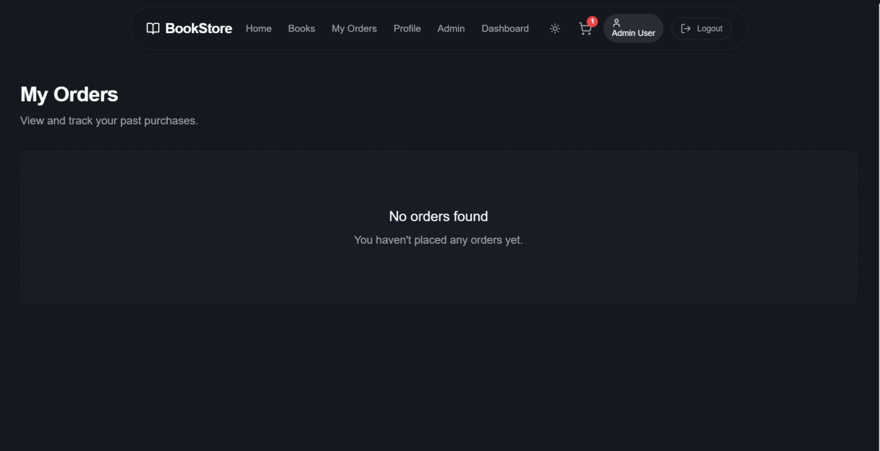
Figure: My Orders
Profile Page
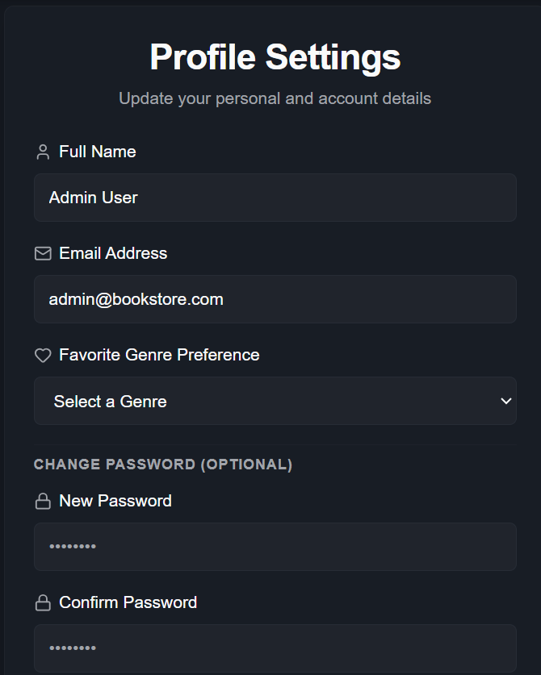
Figure: Profile Page
Admin Dashboard
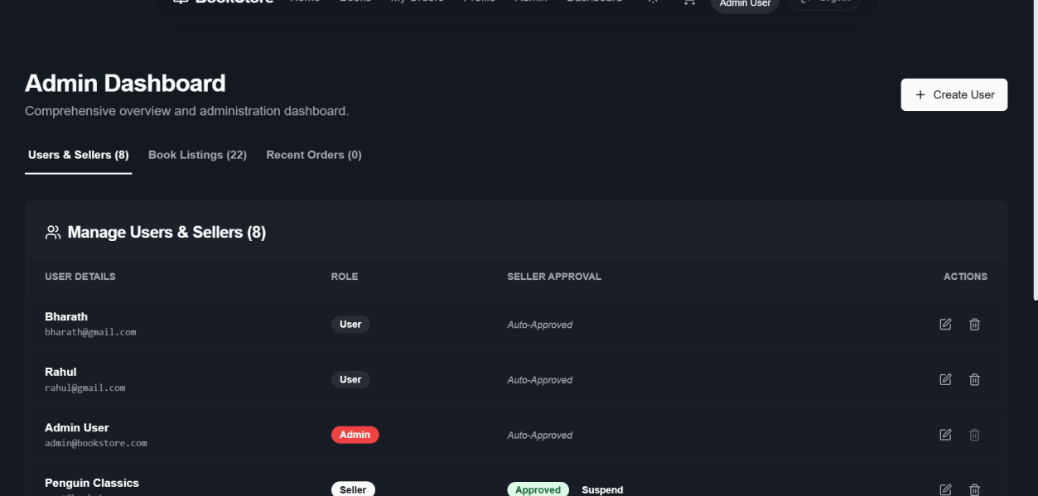
Figure: Admin Dashboard
Organizer Dashboard
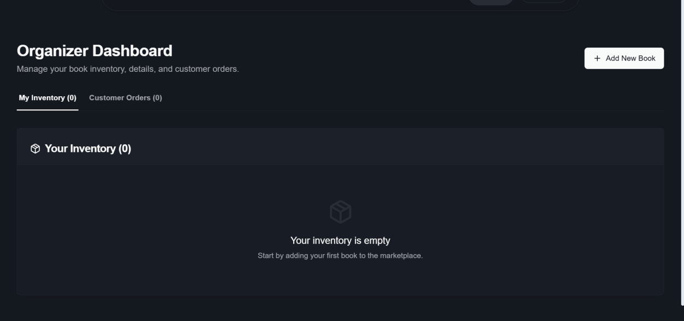
Figure: Organizer Dashboard
Cart Page

Figure: Cart Page

8. Advantages & Disadvantages
Advantages
- 24/7 access to a searchable book catalog without the constraints of physical store hours
- Transparent pricing, ratings, and reviews support informed purchasing decisions
- Real-time order tracking improves customer confidence and reduces support queries
- Dedicated organizer dashboard simplifies inventory and order management
- Centralized admin controls improve platform quality and trust
- Secure JWT-based authentication protects user data
- Modular MVC architecture makes the system easy to extend and maintain
Disadvantages
- Requires reliable internet access, limiting usability in low-connectivity areas
- Customers cannot physically inspect books before purchase
- Dependent on organizers to keep inventory and pricing accurate and up to date
- Initial trust-building is needed for new organizers with no review history
- Additional infrastructure and monitoring are required as user load grows

9. Conclusion
The Bookstore Management System successfully demonstrates a complete, secure, and scalable e-commerce solution for online book selling using the MERN stack. By combining a responsive customer-facing shopping experience with dedicated organizer and administrator tools, the platform addresses the core limitations of traditional bookstores — restricted hours, limited inventory visibility, and manual record management. User Acceptance Testing confirmed that the majority of core workflows, including registration, login, browsing, cart management, checkout, and order tracking, function as expected, with a small number of minor issues identified and either resolved or scheduled for resolution. The project validates the practical application of RESTful API design, JWT-based authentication, and the MVC architecture in building a production-ready web application.

10. Future Scope
- Integration of online payment gateways for real-time transactions
- Personalized book recommendations using purchase and browsing history
- Wishlist and notification features for price drops and new arrivals
- Mobile application for Android and iOS
- Advanced analytics dashboard for organizers to track sales trends
- Multi-language and multi-currency support for wider reach
- Automated fraud detection for reviews and transactions

11. Appendix
Source Code
[Link to source code repository to be added]
Dataset Link
Not applicable — book catalog data is created and managed directly within the application by organizers rather than sourced from an external dataset.
GitHub & Project Demo Link
GitHub Repository: [Link to be added]
Project Demo Video: [Link to be added]

